Sopheap Sok

so683950

CIS 3360 0R02, Spring 2018

3/23/2018

Programming Assignment 2: Cyclic Redundancy Check (CRC)

How to compile and run crc java file:

1. Type **javac crc.java** to compile.
2. Type **java crc** to run the program.
3. If the inputted message is too long, the error message below will appear, and the program will terminate.

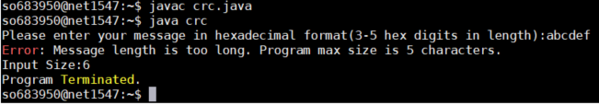

1. If the inputted message is not in hexadecimal, the error message below will appear, and the program will be terminated. This error will be check again after the user is asked to enter a message for verification.

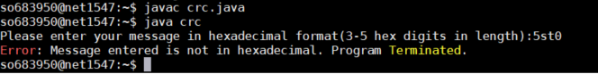

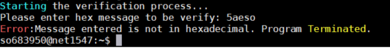

1. Run the program again with the command **java crc** and enter the correct range of characters. The image below should appear.

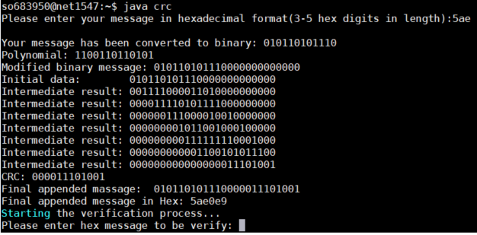

1. At this point the verification process will automatically start and the user will be prompt to enter a message to be verify. If the entered message is different than the CRC given, the screen will show verification failed, as seen from the image below, and the program will end.

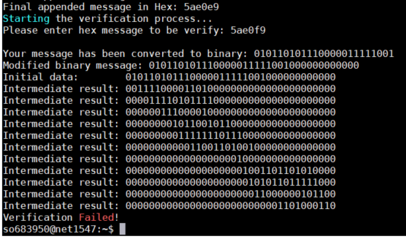

1. If the entered message produced no remainders, the screen will appear as the image below and the program will end.

